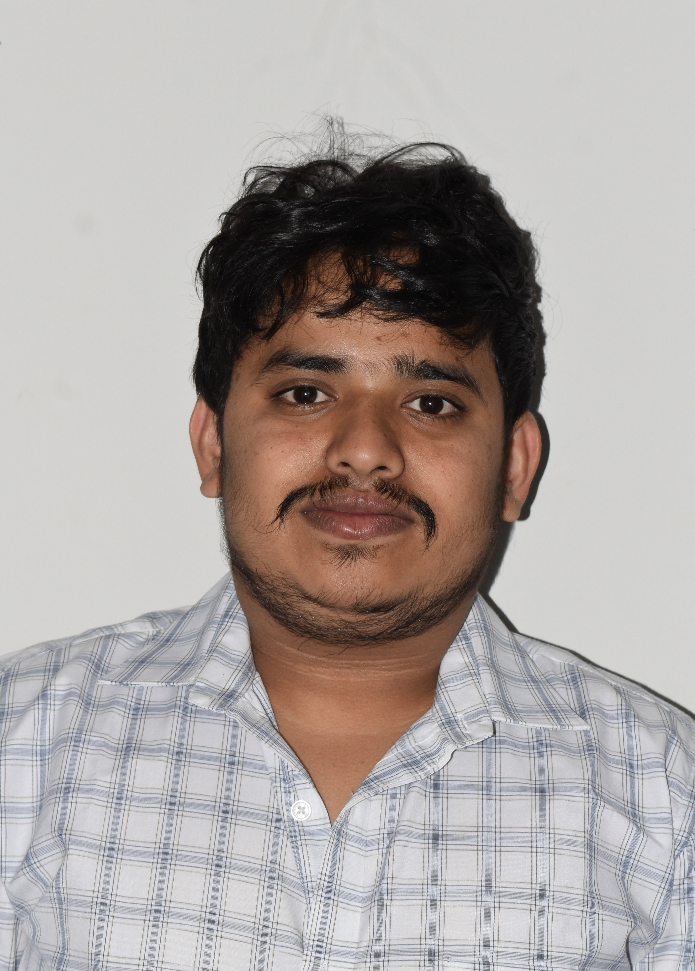

Please affix
your recent
Passport size photograph
EMPLOYMENT APPLICATION FORM

Name in full: Mr. NANDAN K S

Post applied for: MCV-Digital Applications-Specialists

Function : : MCV-Digital Applications

TATA ELXSI WAY OF LIFE

- AGILITY in decision making and action
- CONFIDENCE to take on the world by thinking big and taking risks
- TRANSPARENCY by building trust through openness and sharing
- IMPROVE COLLABORATION as we win when we work together
- OWNERSHIP through commitment, by making it happen and by doing it well
- NURTURE LEARNING AND GROWTH to flourish
Source  (Please Tick) | Yes |  |  | Details of Source:  Name: Gadekatte Panchakshari  Emp id: 28762  Email: gadekatte.p@tataelxi.co.in
Source  (Please Tick) | Employee Referral | Direct | Through Consultant
Note:
- Please read the complete form before filling. If you need any clarification, please get in touch with Talent Acquisition.
- Please be meticulous and provide complete and accurate information. It will help us to process your application faster.
- Avoid ambiguous words or phrases.
- Use extra sheets wherever required.
- Information given by you will be treated in FULLEST CONFIDENCE. It forms the basis of employment, if an offer is made.
- On completion, please handover/mail this form to the Talent Acquisition.

Tata Elxsi Limited, ITPB Road, Whitefield, Bangalore – 560 0 48. INDIA.Phone: 91-80–22979123, Fax: 91 – 80 – 28410152. Website: http://www.tataelxsi.com


PROJECT

1. PERSONAL PROFILE:

FULL NAME : ( As per Passport / Aadhar Card / 10th Standard Certificate)

Mr / Ms : NANDAN KULLUNDE SATHISH
(First) (Middle) (Last)

DATE OF BIRTH : 14/09/96 PLACE : KULLUNDE
(dd/ mm/ yy)

SEX : MALE FEMALE TRANSGENDER NATIONALITY : INDIAN

PASSPORT NUMBER: NA VALID UPTO: NA

COUNTRY OF ISSUE: NA ISSUE DATE: NA
If holding Foreign Passport, Do you hold an OCI registration – YES / NO

OCI No. NA DATE OF ISSUE: NA

PAN CARD No: KAHPS1737K AADHAR CARD No: 4369 2809 9197

BLOOD GROUP: A+ MARITAL STATUS : Single

DATE OF WEDDING: NA MOBILE No: 8971290503

PERSONAL EMAIL ID: nandunaik23@gmail.com

Please tick the right option in the query given below.

Do you belong to SC/ST Yes No as notified by Government of India?
If your answer is YES please attach the necessary proof.

Information sought as per the guidelines of the Affirmative Action Committee of Confederation of Indian
Industries (CII). Please note that this information does not impact our stated policy of equal opportunities employment in any way.

MAILING ADDRESS : | PERMANENT ADDRESS:
S/o Sathish K M, Kullunde (v), Halaga (Po), | S/o Sathish K M, Kullunde (v), Halaga (Po), Thirthahalli (Tq), Shimoga (Dist),
Thirthahalli (Tq), Shimoga (Dist), Karnataka, | Karnataka,
577220 | 577220
PIN: 577220 PHONE: 8971290503 | PIN: 577220 PHONE: 8971290503

FAMILY PARTICULARS : (Fill in details of parents and direct family members only)
RELATIONSHIP | NAME | OCCUPATION | CONTACT DETAILS
Father | Sathish K M | Farmer | 9900556392
Mother | Pushpa E P | House wife | 9900556392
Spouse | NA
Child | NA
Child | NA
Brother | Naveen K S | DCB Bank | 9008903421
Brother / Sister

2. ACADEMIC QUALIFICATION AND PROFESSIONAL TRAINING:
ACADEMIC RECORD (Please enter details in chronological order, beginning with standard X)

QUALIFICATION DEGREE/DIPLOMA/  CERTIFICATE | UNIVERSITY/  INSTITUTE/  SCHOOL/  COLLEGE | MONTH & YEAR OF PASSING | DURATION (SPECIFY IN MONTH/YR)  FROM : TO: | % OF MARKS/  CLASS/  DEVISION | MAJOR  SUBJECTS
Class X | Sri Malenadu English  Medium composite High School, Bejjavalli | April  2013 | April 2012 –  April 2013 | 67.36% | Karnataka State syllabus
Diploma | DVS Polytechnic, Shimoga,  University: Board of technical education, Bangalore | Jun  2016 | Jun-2013 to  Jun-2016 | 62% | Diploma in  Electronics & communication
BE | JNNCE, Shimoga,  University: VTU Belegaum | Jul  2020 | Jul-2016 to  Jul-2020 | CGPA-6.0 | Electronics &  Communication  Engineering

Significant achievements in your academic career:
___________________________________________________________________________________

State reasons for gaps in education, if any : 1 year gap during BE in 2017 due to health issues
Due to operated Brain tumor.

PROFESSIONAL TRAINING ATTENDED
NAME OF THE INSTITUTION | DURATION/PERIOD | AREA OF TRAINING
Bessant Technologies | 5 month | C# dot net
Bessant Technologies | 3 month | Angular-08
Mention any other efforts you have made/are making to improve your skills and knowledge:
did course on HTML, CSS, Bootstrap training in UDEMY

__________________________________________________________________________________

3. CURRENT EMPLOYMENT DETAILS:

NAME & ADDRESS OF ORGANIZATION | DESIGNATION
Acuity knowledge partners pvt ltd | Joining: | May-2021
Acuity knowledge partners pvt ltd | Present: | Aug-2023
Acuity knowledge partners pvt ltd | Duration of service from: May-2021 to: Aug-2023
Acuity knowledge partners pvt ltd | Name & Designation of your immediate superior:  Specialized solution Analyst
Total manpower: 6000 | Phone/ Mobile: 8971290503

Draw your organization chart and indicate your position: | Brief job description:
Director  Associate  Director  Delivery  Manager  Analyst | Working as a full stack developer by getting the requirements from the customer like adding new feature or modifying the existing feature of the application and maintain the tool by version migration and the takes role in the delivery of the project

PROJECTS UNDERTAKEN:

TITLE | YOUR ROLE | SOFTWARE /OS | CLIENT
FolioSure | Full stack softaware developer | Visual Studio 2019,  Visual studio code,  SSMS, Git, JIRA | Himera
Guideline Compliance Management tool | Full stack softaware developer | Visual Studio 2022,  Visual studio code,  SSMS, Git, JIRA | Internal  Compliance tool
Fund-Metrix | Backend web-api developer | Visual Studio 2022,  Git,JIRA,  SSMS | Internal Product

Reasons for seeking a change in employment:
Due to carrier growth

4. EMPLOYMENT HISTORY
- Exclude current employment
- Enter details in reverse chronological order
- Use extra sheets if required

1) NAME & ADDRESS OF ORGANIZATION | DESIGNATION |  | GROSS SALARY  (Per annum)
Phone/Mobile: | Starting |  | Starting
Phone/Mobile: | Leaving |  | Leaving
Phone/Mobile: | Duration of service from: to:
Phone/Mobile: | Name, Designation of your superior:

PROJECTS UNDERTAKEN:

TITLE | YOUR ROLE | SOFTWARE /OS | CLIENT

Reasons for seeking a change in employment:

2) NAME & ADDRESS OF ORGANIZATION | DESIGNATION |  | GROSS SALARY  (Per annum)
Phone/Mobile: | Starting |  | Starting
Phone/Mobile: | Leaving |  | Leaving
Phone/Mobile: | Duration of service from: to:
Phone/Mobile: | Name, Designation of your superior:

PROJECTS UNDERTAKEN:

TITLE | YOUR ROLE | SOFTWARE /OS | CLIENT

Reasons for seeking a change in employment:

ACHIEVEMENTS AND ASPIRATIONS
Specify significant contributions you have made in various positions during your career:
My work experience includes innovation in many areas, including strategies for more effective
Teamwork. I devised strategies for improving teamwork and communication
Among members of team projects.
Brief note on your career goals:
As a software engineer, I will stay updated with the latest technologies
Trends in the industry. So, the first great goal would be to continuously upskill myself by attending
Workshops, taking online courses, or earning certifications pertinent to your field. Yet, expanding my
Programming language repertoire is always beneficial as it widens your horizons. Another fantastic goal
Could be working towards becoming a subject matter expert in a specific area of software development.
And to fulfill customer requirement and timely delivery of the project.
What are your expectations from this job?
I would like to have a lot of opportunities to learn new technology and tools. This will help myself grow
Personally in terms of knowledge and a better growth.
Additional information, if any, on your special abilities, experiences, achievements, extracurricular activities etc., to which you would like to draw attention:

5. COMPENSATION DETAILS:

Components | Current Salary Rs. | Taxable/Not Taxable | Expected Salary at  Tata Elxsi Rs. | For Tata Elxsi use
1. Basic | 20,872 | Not taxable
2. HRA | 8,349
3. Conveyance | 10,723
4.P F | 1800
5.
6.
7.
8.
9.
Monthly Total | 41745
A) Monthly  Total X 12  (1 to 9) | 500938 |  | 80000
Annual Benefits:
10 LTA
11 Medical
12 Bonus | 50000
13 P F
14.
15.
16.
17.
B) Total 10 to 17 | 50000
Gross Total  Total of A & B | 550938 |  | 960000
- Please enclose a copy of your latest pay slip.
2. You would be required to submit a proof of salary prior to joining.

6. PERSONAL REFERENCES:
Details of three persons who are not Relatives / Friends, for reference)

Name and address | Phone | Occupation | Relationship
Hruthvik | 6362926842 | Software engineer | colleague
Gouthaman B G | 8148063822 | Software engineer | colleague
Keshava Chandrappa | 8310346152 | Software  engineer | colleague

Are you related to anyone or do you know anyone presently working for our company? (Yes/No) If Yes, please specify:

Name: Gadekatte Panchakshari Relationship: Friend

________________________________________________________________________________________________

Are you suffering from any ailment/illness or disability which may hamper normal performance of your duties at work (Yes/No) If Yes, give details. NO

Have you applied to our company before? (Yes/No) If Yes, position applied for and date: No

________________________________________________________________________________________________

Have you ever been convicted in a courts of law ? (Yes/No) If Yes, Give details: No

________________________________________________________________________________________________

Are you willing to work on overseas assignments? (Yes/No) If No, reasons? Yes
________________________________________________________________________________________________

If selected, time period required for joining: 90 days

DECLARATION BY APPLICANT:
I confirm that the information provided by me in this application form is accurate. And I understand that in the event of any information found to be incorrect, it could result in the termination of my employment without notice.

Date : 14/08/2023

Place: Kullunde Signature: Nandan K S

We thank you for all the efforts put in to complete this application.

